

$2,452.00

27

14

SUNDAY

February 13

2022

Kay Magee

Denna Sadler

Sara Borden

Melba Ward

Nancy Tarter

Molly Yeager

Ruth & Emily Neyland

Johnnie & Olga Rivera

Delia Dutchover

The Eckhart Family

Christian McKee,

Leukemia

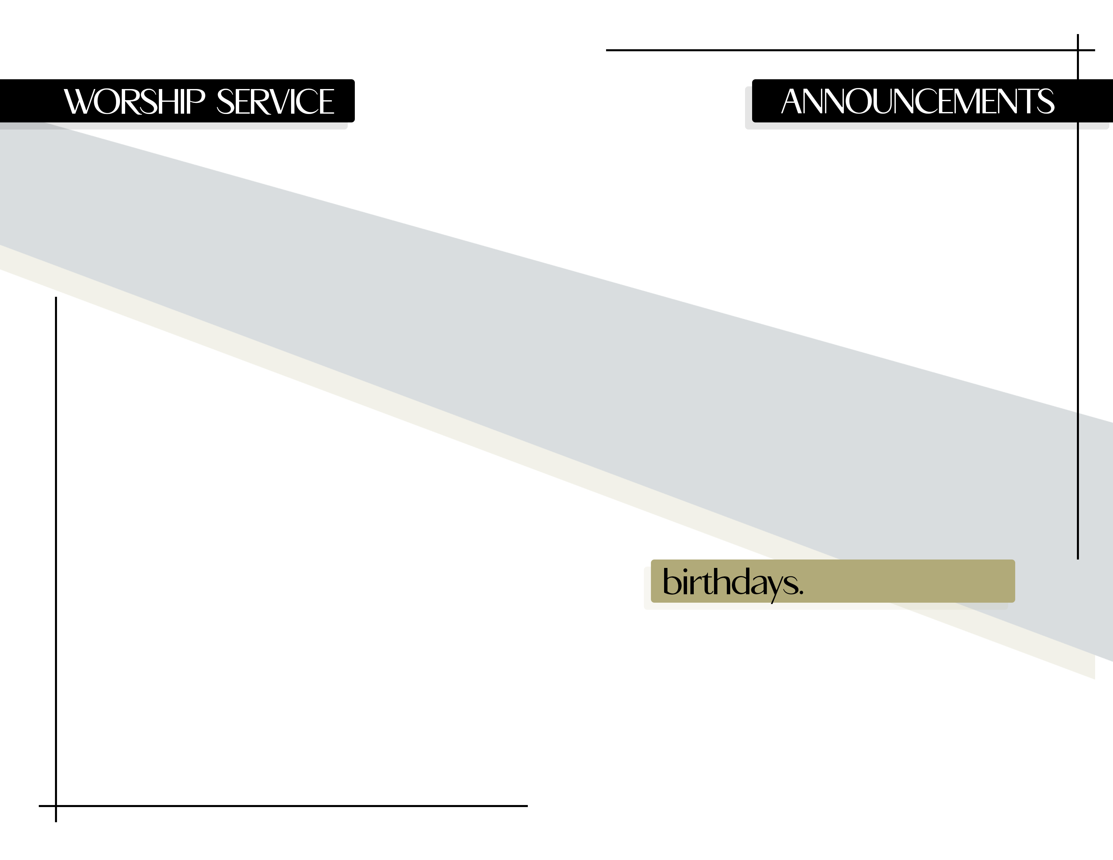

7 PM 2/16 & 2/23

Confirmation Classes Begin

Ask VG for details!

Youth Classes Begin!

Our youth will be following the UMC curriculum “Gathering Up in Jesus” led by Christina

Tell us your favorite hymns!

MARCH

Bible Study

2/28

YOU PICK

Victory in Jesus # 370

Blessed Assurance #369

1 Corinthians 3:6-9

God Who Gives the Growth

by Efrain Belmontes

welcome

opening hymn

morning prayer

hymn of praise

children’s sermon

scripture

message

offering

benediction

Alexis Duarte – February 14

Christina Duarte – February 15

Glynetta Card – February 21

Ruth Neyland – February 24