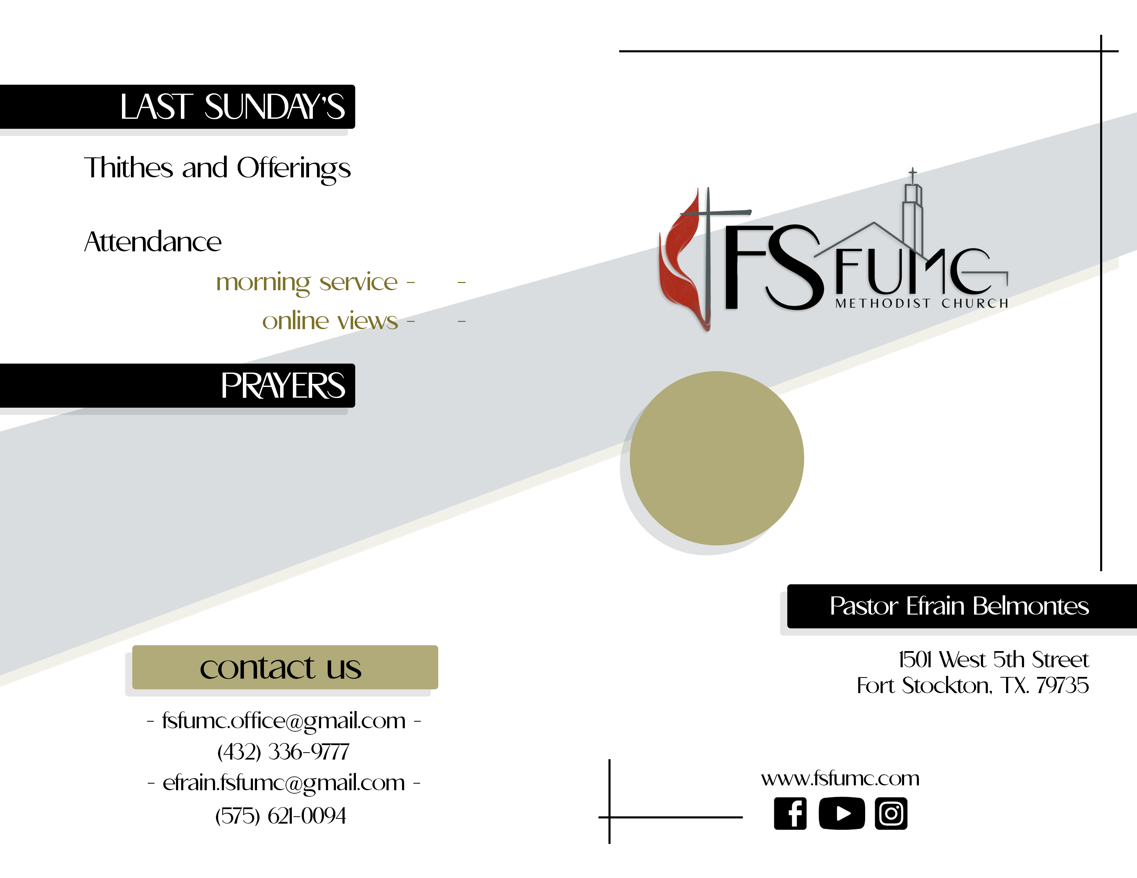

$2,285

35

18

SUNDAY

August 1

2021

The Yeager Family

Charles Neebs,

Ruth and Emily Neyland

Johnnie & Olga Rivera

Toni Terrazas & Family

Kay Magee

Denna Sadler

Sara Borden

Melba Ward

Shawn Beeles

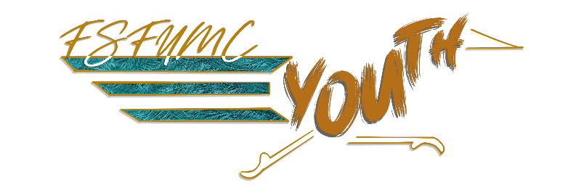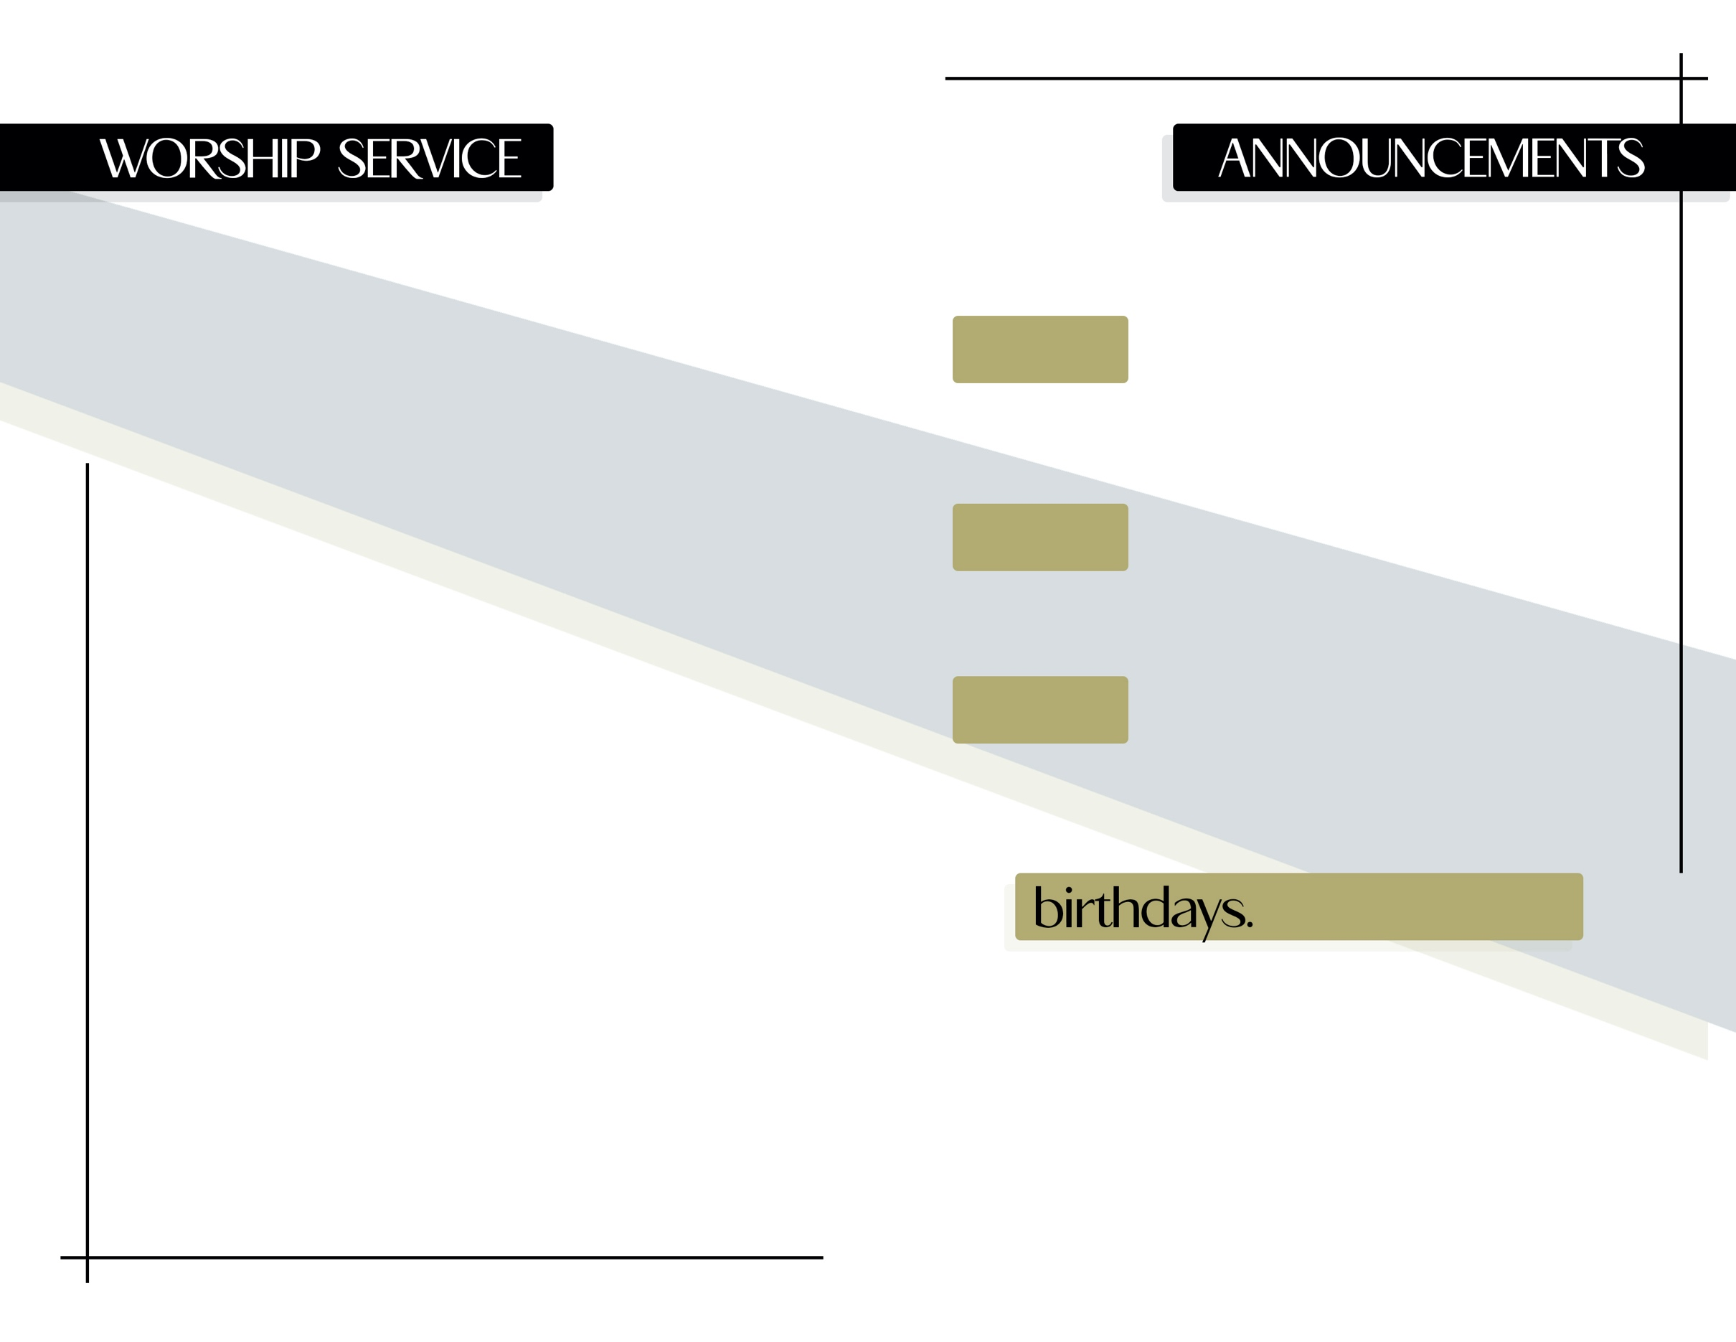

Molly Yeager – August 2

Viola Duarte – August 2

Brett Magee – August 8

Delmon Hodges – August 9

His Name Is Wonderful # 174

This Is The Day # 657

Luke 5:27-31

“EVERYONE AT THE TABLE”

by Efrain Belmontes

prelude

welcome

call to worship

opening prayer

hymn of praise

morning prayer

children’s sermon

scripture lesson

message

benediction

Have you seen this?

Our new youth logo: